**- RSH321 –**

# SMART CLEAN Electrical

# POWER DISTRIBUTION done BY Artificial intelligence

By

Michiel Van der Merwe

9707315151085

Submitted in partial fulfillment of the requirements for the degree in

Computer Science

The Belgium Campus

Supervisor:

Mrs. A. Joy

Co-Supervisor:

Mr. C. Kajengo & Mrs. A. Joy

Date of submission

16/05/2018

# ABSTRACT

The Greenhouse effect is a major issue in the world and people are starting to realize that. This is one of the major reasons behind why clean electrical energy is becoming such a big deal and why more and more people is starting to join the “green revelation” this is very good but alas there is a big problem with the integration of this type of power into an existing electrical grid that is the hole distribution of the clean energy over the electrical grid is handled very ineffectively and this cause a lot of different problems.

In South Africa we have a lot of clean resources that is starting to be used and as the size of these type of electrical grids grow, mistakes that the operators can make shirks in size as the grid size increases mistakes can become costly affairs. This is being one would want to integrate some sort of Artificial intelligence to handle all the statistical and Probabilistic dissections that normal humans will not be able to do as fast as the Artificial intelligence algorithm.

Artificial intelligence will never completely replace operators because an Artificial intelligence algorithm has no humanity and we will struggle to get to that point in our society where we would be able to replace humans but this is not the desiccation of this papier, this papier is more to do with analysis of the plausibility of such an integration of Artificial intelligence into a clean electrical energy grid

DECLARATION

“I hereby declare that this document: SMART CLEAN ELECTRICAL POWER DISTRIBUTION DONE BY ARTIFICIAL INTELLIGENCE, submitted for evaluation towards the requirements of the subject: RSH321 as part of the Degree in Computer Science, at the Belgium Campus, is my own original work and has not previously been submitted to any other institution of higher learning or subject for evaluation. All sources used or quoted in this document are indicated and acknowledged by means of a comprehensive list of references”.

Van Der merwe, M.F:

9707315151085:

Signature _______M.F.__________ Date: 02/19/2018

TABLE OF CONTENTS

SMART CLEAN Electrical i

POWER DISTRIBUTION done BY Artificial intelligence i

ABSTRACT ii

SMART CLEAN Electrical 1

POWER DISTRIBUTION done BY Artificial intelligence 1

CHAPTER 1: INTRODUCTION 1

1.1. BACKGROUND 1

1.2. PROBLEM STATEMENT AND RESEARCH QUESTIONS 1

1.2.1. Reason for research 1

1.2.2. Problem statement 1

1.2.3. Research question 2

1.2.3.1. MArtificial intelligence n research question 2

1.2.4. Research objective 2

1.3. PRELIMINARY LITERATURE REVIEW 2

1.3.1. Artificial intelligence 2

1.3.2. Solar energy 3

1.3.3. Wind energy 3

1.4. IMPORTANCE OF THE STUDY 4

1.5. RESEARCH METHODOLOGY 4

1.5.1. Research design 4

1.5.2. Methodology 5

1.5.3. Data collection 5

1.5.4. Population and sample 5

1.5.5. Data analysis 6

1.6. DELINEATIONS AND LIMITATIONS 6

1.7. ASSUMPTIONS 6

1.8. ETHICAL CONSIDERATIONS 7

1.9. CHAPTER OUTLINE/OVERVIEW 8

1.10. CONCLUSION 8

CHAPTER 2: LITERATURE STUDY 10

2.1. INTRODUCTION 10

2.2. KEY CONCEPTS 10

2.2.1. Artificial intelligence 10

2.2.2. Solar energy 11

2.2.3. wind Energy 13

2.3. CONCLUSION 14

2.3.1. Hybrid system 14

14

CHAPTER 3: METHODOLOGY 16

3.1. INTRODUCTION 16

3.2. RESEARCH QUESTION 16

3.3. RESEARCH PHILOSOPHY 16

3.4. RESEARCH APPROACH 17

3.5. POPULATION AND SAMPLING 19

3.6. DATA COLLECTION 20

3.7. DATA ANALYSIS 21

3.8. LIMITATIONS 22

3.9. ETHICAL CONSIDERATIONS 22

3.10. TRUSTWORTHINESS 23

3.11. CONCLUSION 24

CHAPTER 4: RESULTS AND CONCLUSIONS 24

4.1. INTRODUCTION 24

4.2. THE RESEARCH PROBLEM AND QUESTION 24

4.3. DISCUSSION OF RESULTS 25

4.4. FINDINGS 31

4.5. DISCUSSION OF CONCLUSIONS 33

4.6. RESEARCH QUESTION ANSWERED? 34

4.7. EXCEPTIONS 35

4.8. SHORTCOMINGS AND LIMITATIONS 35

4.9. RECOMMENDATIONS 35

4.10. BENEFITS TO THE FIELD OF STUDY 36

4.11. PROPOSED NEW RESEARCH 36

4.12. FINAL CONCLUSION 37

REFERENCES 38

Anney, V. N., 2014. Ensuring the Quality of the Findings of Qualitative Research:. *Journal of Emerging Trends in Educational Research and Policy Studies ,* pp. 272-281. 38

APPENDIX A: DATA COLLECTION INSTRUMENTS 40

APPENDIX B: LETTERS OF PERMISSION AND CONSENT 41

APPENDIX C: TOPIC 42

Figure 1.3.1.1 A basic solar cell (Hantula, 2010) 3

Figure 2 1.9.CHAPTER OUTLINE/OVERVIEW (Researcher, 2018) 8

Figure 3.3.1 Wind Solar hybrid system (Vaibhav J. Babrekar, 2017) 14

Figure 4 Deductive Approach (socialresearchmethods, 2018) 18

Figure 5 Inductive Approach (Dudovskiy, 2018) 19

# SMART CLEAN Electrical

# POWER DISTRIBUTION done BY Artificial intelligence

# CHAPTER 1: INTRODUCTION

## BACKGROUND

Artificial intelligence (AI) it refers to the ability of a machine to learn and improve existing protocols. Clean energy refers to the creating power via wind and solar means etc. it basically means generating power from sources that cannot exhausted. The world has started to Realize the need for clean energy and there are a lot of already very successful countries in the world that have implemented clean energy solutions but the way the power distribution is handled will became a problem in the future as the demand for electrical power increases. This is where Artificial intelligence comes in to play, the use of this type of technology will help a lot in the quest for a more efficient power gird management and especially in clean power distribution.

## PROBLEM STATEMENT AND RESEARCH QUESTIONS

### Reason for research

Traditional ways of generating power (fossil fuel burning) is contributing a lot to global warming and is not cutting it anymore and the world is realizing it. The way the clean electrical power grid is managed and distributed is handled is not very effective. Artificial intelligence is continuously evolving and is becoming more advance thus the idea to do research on how it can befit man kind in the long run to incorporate Artificial intelligence and power distribution into one functional system.

### Problem statement

Clean electrical power distribution refers to the ability to generate electricity for renewable resources (for the purpose of this paper the researcher will be focusing on only solar and wind energy). The biggest problem that we are facing is the way clean electrical power is managed and distributed is not very effective and will become a problem as the world is advancing and the demand for this type of energy increases. We as humans make mistakes and this is where the ARTIFICIAL INTELLIGENCE comes into play the problem that stands before us is that peoples judgment is influenced by their emotions and that means that mistakes do happen.

### Research question

### MArtificial intelligence n research question

How will ARTIFICIAL INTELLIGENCE effect clean electrical power distribution?

### Research objective

The objectives of this research paper, to prove that the current systems that are responsible for management and distribution is not effective at all the solution to this is Artificial intelligence and this is the papers objective.

## PRELIMINARY LITERATURE REVIEW

Traditionally, the term grid is used for an electricity system that may support all or some of the following four operations: electricity generation, electricity transmission, electricity distribution, and electricity control, as stated by (Xi Fang, 2017).There have been previous researchers that have do some research on the concept of smart grids but none of them has mentioned the concept of integrating Artificial intelligence into the systems. This papier will focus on some case studies but the research core will be on how clean energy is generated and distributed and how ARTIFICIAL INTELLIGENCE works and how it can help improve the systems.

### Artificial intelligence

The ability of a digital [computer](https://www.britannica.com/technology/computer) or computer-controlled [robot](https://www.britannica.com/technology/robot-technology) to perform tasks commonly associated with intelligent beings. The term is frequently applied to the project of developing systems endowed with the [intellectual](https://www.merriam-webster.com/dictionary/intellectual) processes characteristic of humans, such as the ability to reason, discover meaning, generalize, or learn from past experience. Since the development of the [digital computer](https://www.britannica.com/technology/digital-computer) in the 1940s, it has been demonstrated that computers can be programmed to carry out very complex tasks—as, for example, discovering proofs for mathematical theorems or playing [chess](https://www.britannica.com/topic/chess)—with great proficiency. Still, despite continuing advances in computer processing speed and memory capacity, there are as yet no programs that can match human flexibility over wider domains or in tasks requiring much everyday knowledge. On the other hand, some programs have attained the performance levels of human experts and professionals in performing certain specific tasks, so that artificial intelligence in this limited sense is found in applications as [diverse](https://www.merriam-webster.com/dictionary/diverse) as medical [diagnosis](https://www.merriam-webster.com/dictionary/diagnosis), computer [search engines](https://www.britannica.com/technology/search-engine), and voice or handwriting recognition as stated by (Copeland, 2018). The concept of a system that can think seems impossible but there are cars that drive them self’s (Tesla car) but you may say but that’s just sensors that accumulates data then that data is interpreted by a computer and then based on how the algorithm parameters stratification the computer makes a decision well you are correct that is exactly what Artificial intelligence is well less advance ARTIFICIAL INTELLIGENCE that is. There is a very big difference between True ARTIFICIAL INTELLIGENCE and well basically “dumper ARTIFICIAL INTELLIGENCE”.

### Solar energy

Atoms take in electromagnetic radiation (such as light) and then give off electrons. This process is called the photoelectric effect. The process of making electricity begins when the silicon atoms absorb some light. The light’s energy knocks some electrons out of the atoms. The electrons flow between the two layers the flow makes an electric current, as stated by (Hantula, 2010)

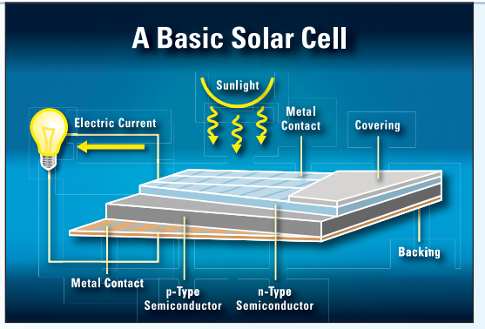

Figure 1.3.1.1 A basic solar cell (Hantula, 2010)

### Wind energy

Generating electricity from the wind is simple: Wind passes over the blades exerting a turning force. The rotating blades turn a shaft inside the nacelle, which goes into a gearbox. The gearbox increases the rotation speed for the generator, which uses magnetic fields to convert the rotational energy into electrical energy. The power output goes to a transformer, which converts the electricity from the generator says (Association, 2004)

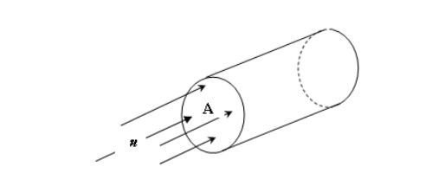

Figure 1.3.3 Basic idea behind wind energy (Bekele, 2009)

## IMPORTANCE OF THE STUDY

This study is very important because of a couple of facts, it will answer what ARTIFICIAL INTELLIGENCE is and how it can befit humanity in the long run and how clean energy works and how it is distributed, what a smart grid is and how all these different systems can be incorporated into one system that can help increase the amount of clean energy that is generated and the amount distributed. The study will benefit countries that have the natural resources and the infrastructure to produce clean energy but their current way of doing it is not very effective so this paper will help them understand how ARTIFICIAL INTELLIGENCE can help the in achieving a more profitable and more effective distribution network and how they can incorporate their current grid and their clean grid. Seeing as there are a lot research on how smart grids work, very few (if any) suggested the use of a ARTIFICIAL INTELLIGENCE system to handle the distribution.

## RESEARCH METHODOLOGY

### Research design

In this dissertation the researcher will be using both qualitative and quantitative approaches to test the research question.

Qualitative approach will be done by using case studies and previous research done by external sources on smart grids and Artificial intelligence each of these topics separately. Quantitative approach will be done by using surveys and then using statistical analysis on the data collected by the surveys to prove the research question the big disadvantage of using the quantitative approach is that the surveys will be filled in by mostly non-experts in the field of smart power and Artificial intelligence so the data should be truly checked and each piece must be critically analyzed. The advantage of using the quantitative approach is that u can get a lot of different personal views in to the matter at hand. The disadvantage of using the qualitative approach is that there are different types of research done one smart grids and separately form how Artificial intelligence works but very little on the two combined. Advantage of using the qualitative approach is that the papers was done by experts in their respective fields.

### Methodology

Qualitative methods will be conducted by using different research papers that were written by a bunch of different researchers so by using that researcher the researcher will conduct a case study to have a theoretical understanding on how a system works and use that as answer for the research question. Quantitative approach will be done by disturbing surveys to deferent people to collect data then from this data I will be using statistical algorithms to test the hypothesis and the all the questions that were not answered by the qualitative method will be answered by the information from the surveys. The nature of This researcher papier is Exploratory in nature seeing as there are already divined theories on Artificial intelligences and clean energy.

### Data collection

Data will be collected with the use of surveys that will consist of various questions aimed at all parts of the society. The reliability of the survey will be solely dependent on the surveyed person, with assistance provided by a surveyor handing out and receiving the surveys. The surveys will also be provided by a google survey service.

The data which will be required will be sufficient if a total of at least 20 or more people participate in the survey. The data which will be collected will also measure what is required, because a limited amount of options will be provided to the person conducting the survey.

### Population and sample

The sampling technique which will be used is stratified sampling which is used when there are specific sub-groups to investigate.

The sampling will occur where a n amount of random people on the street are questioned for their opinions as well as random people in government and medical establishments. The reason for the specific sub-group division is to try and identify the opinions from people who will implement and use the system for example operators in the energy sector and people whom use electricity every day

The surveyed people’s opinions will give vital information towards the option of this type of integration possible features which can be included as well as the thoughts on the effectiveness if it were to be implemented.

The amount of people included in the sample, will be as much as possible with both sub-groups having the same average amount of people who conducted the survey.

### Data analysis

The only data that will be analyzed will be the data from the surveys, seeing as the case studies will come from trusted sources so the information does not be refined to draw a conclusion. The survey data will be refined by using hypothesis testing algorithm and all the correlating statistical algorithms to refine the data so that it is less technical and more readable and understandable. The existing literature on the subject will sourced and use as a prove that the concept is not far-fetched and that it is not only theoretical possible but also practically doable and more immortally it is implementable.

## DELINEATIONS AND LIMITATIONS

This paper is responsible for a theoretical background and research on if an Artificial intelligence could be integrated, how effective will it be, this research is purely theoretical and hasn’t been tested practically that doesn’t mean that the hypothesis is far fetch all the ideas that will be mentioned and tested theoretically and mathematically will be in the realm of possibility. This research paper can be used as prove in the future if someone wants to implement the idea practically. Keep in mind that the surveys data comes from non-experts so that means that the data is strongly opinion based but the that means that all the statically algorithms answers are opinion based as well but in the future the people’s opinion may change as Artificial intelligence and clean energy gets more common placed, Future researchers may prove my algorithms answers wrong, based on their surveys.

## ASSUMPTIONS

There are certain assumptions that can be assumed is that ARTIFICIAL INTELLIGENCE technology exists and that it is functional in such a way that it can be implemented without a lot of change to the existing algorithm. There is also an assumption that clean energy is incompatible in to any smart grid what the researcher means by this is that if clean energy was to be implemented in to the any of the current grids compatibility issues is going to arise of course but these problems are fixable. When the researcher refers to clean energy the assumption should be only wind and solar energy as stated in the title. Hydroelectricity is not included when the researcher speaks about clean energy. As stated previously the surveys data is coming from non-experts but the information that is derived from the data (via statistics) can be used as a reference. When the researcher refers to ARTIFICIAL INTELLIGENCE the assumption should be that he/she is speaking about Artificial intelligence also when he/she speaks about grid they refer to an electrical grid.

## ETHICAL CONSIDERATIONS

The Ethical consideration that must be considered in the research of this paper is that people answering the surveys might be biased in answering the question because of being afraid that their answers will be mentioned in the research that is why the researcher must say in the introduction of the survey that their names and surnames will be kept confidential between the researcher and the organization called Belgium campus. They will only be asked to fill in their name and surname as well as their email address so if the researcher have more questions on something they might have selected him/her will be able to contact them.

## CHAPTER OUTLINE/OVERVIEW

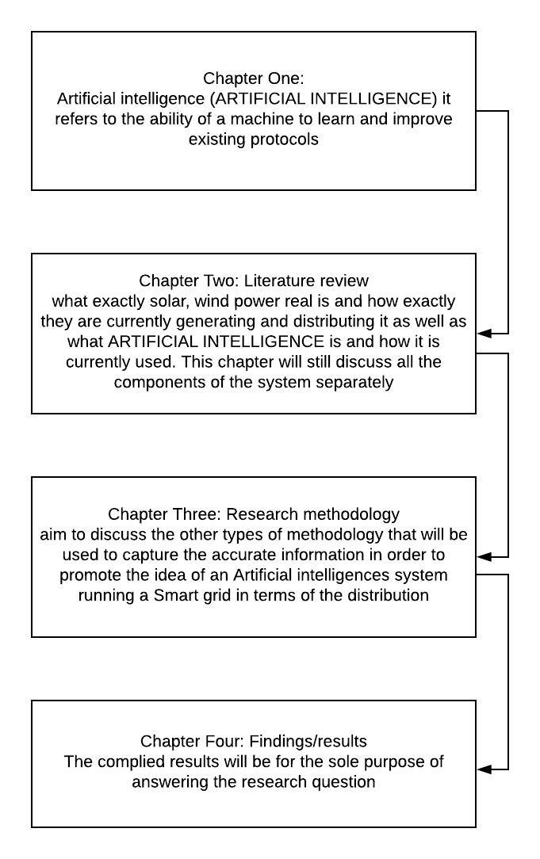

Figure 2 1.9.CHAPTER OUTLINE/OVERVIEW (Researcher, 2018)

## CONCLUSION

In conclusion there is a big need for clean energy and companies and contraries are realizing it. There have been some ideas around the generation of clean energy but the researcher feels that if it were to become a thing and be integrated into the power grid the distribution of this new clean energy will not be effective at all so the research will be focusing on who we can achieve the desired results by the use of an ARTIFICIAL INTELLIGENCE system that can learn protocols and improve it thus indirectly improving the way the energy distribution is handled.

# CHAPTER 2: LITERATURE STUDY

## INTRODUCTION

In first chapter the conclusion that the researcher came to was that there is a big need for solar and wind electrical energy generation and even a bigger need for an effective way to integrate and distribute this type of electrical power. In this chapter there will be a discussion on what exactly solar, wind power real is and how exactly they are currently generating and distributing it as well as what ARTIFICIAL INTELLIGENCE is and how it is currently used. This chapter will still discuss all the components of the system separately and only at the end discuss how the 2 systems can be incorporated into one system. Basically, this chapter is to give you an idea on what the different individual systems do and how they would function in their own “echo system”.

## KEY CONCEPTS

### Artificial intelligence

Computationally is the theory that the human brain essentially a computer, although presumably not a stored-program, digital computer. Artificial intelligence (ARTIFICIAL INTELLIGENCE) is a field of computer science that explores computational models of problem solving, where the problems to be solved are of the complexity of problems solved by human beings. (McDermott, 2007)

Artificial intelligence is the study and developments of intelligent machines and software that can reason, learn, gather knowledge, communicate, manipulate and perceive the objects. John McCarthy coined the term in 1956 as branch of computer science concerned with making computers behave like humans. It is the study of the computation that makes it possible to perceive reason and act. Artificial intelligence is different from psychology because it emphasis on computation and is different from computer science because of its emphasis on perception, reasoning and action. It makes machines smarter and more useful said the (Avneet Pannu, 2015).

The idea behind that a machine can have true human intelligence seems upsurge maybe unreal even like science function but it’s not there are actually more systems than you think that already some kind of ARTIFICIAL INTELLIGENCE integration as previously explain there is a very big difference between true ARTIFICIAL INTELLIGENCE and a “Dumber ARTIFICIAL INTELLIGENCE ” for the purpose of this research paper the researcher will be focusing on dumb Artificial intelligence because as of today there has not been a lot of research done on the idea of computers rewriting existing protocols become a fully sentient object but that maybe the case in the future as technology progresses an become more advance each day there is a big possibility that true ARTIFICIAL INTELLIGENCE may be a possibility.

In narrow, well-tested areas of application, such as driverless cars and certain areas of medical diagnostics, the superiority of ARTIFICIAL INTELLIGENCE s over humans is already established. An increased use of technology in these areas offers great potential, including fewer road traffic accidents, fewer mistakes in the medical treatment and diagnosing of patients, and the discovery of many new therapies and pharmaceuticals. In complex systems where several algorithms interact at high speed (such as in the financial market or in foreseeable military uses), there is a heightened risk that new ARTIFICIAL INTELLIGENCE technologies will be misused or will experience unexpected systematic failures.

(Foundational Research Institute, 2015)

There is also the threat of an arms race in which the safety of technological developments is sacrificed in favor of rapid progress. In any case, it is crucial to know which goals or ethical values ought to be programmed into ARTIFICIAL INTELLIGENCE algorithms and to have a technical guarantee that the goals remain stable and resistant to manipulation. With driverless cars, for instance, there is the well-known question of how the algorithm should act if a collision with several pedestrians can only be avoided by endangering the passenger(s), not to mention how it can be ensured that the algorithms of driverless cars are not at risk of hacking systematic failure.

(Foundational Research Institute, 2015)

### Solar energy

Solar energy is one of earth’s most important resources. The sun is life it is one of the most important factors in photosynthesis and the processes gives us oxygen that makes up our atmosphere and one of the components us humans need to live. What the researcher is trying to say is that sun is really important for life and that this source of energy can be used to do much more like for instance generate electrical power. What the researcher is saying is not a new concept it has been practically implement i.e. solar panels or solar farms that produce a lot of Kilowatts.

Solar energy has experienced an impressive technological shift. While early solar technologies consisted of small-scale photovoltaic (PV) cells, recent technologies are represented by solar concentrated power (CSP) and also by large-scale PV systems that feed into electricity grids. The costs of solar energy technologies have dropped substantially over the last 30 years. For example, the cost of high power band solar modules has decreased from about $27,000/kW in 1982 to about $4,000/kW in 2006; the installed cost of a PV system declined from $16,000/kW in 1992 to around $6,000/kW in 2008 (Govinda R. Timilsina, 2011).

Solar radiation represents the largest energy flow entering the terrestrial ecosystem. After reflection and absorption in the atmosphere, some 100,000TW hit the surface of Earth and undergo conversion to all forms of energy used by humans, with the exception of nuclear, geothermal, and tidal energy. This resource is enormous and corresponds to almost 6,000-fold the current global consumption of primary energy (13.7TW [1]). Thus, solar energy has the potential of becoming a major component of a sustainable energy portfolio with constrained greenhouse gas emissions. (Geoffrey Jones, 2012)

Were climate change of no concern, a natural, gradual shift to solar energy technologies might be envisaged as conventional energy sources become depleted and housing stock over the next century is replaced and upgraded. However, to make a significant contribution to the problem of climate change, an accelerated adoption of solar energy technologies is required. Appropriately designed feed-in-tariffs have proven to be effective in achieving this with photovoltaic, driving both technological development and market expansion and providing the motivation to overcome non-technical barriers such as limited training and local installation expertise. Solar electricity technologies require roughly another decade of government support to achieve sufficient cost reduction with present technologies to enable them to become self-sustaining. The International Energy Agency (IEA) predicts that approximately one quarter of renewable power, or 11% of worldwide electricity, could be supplied from solar energy in 20504 (Figure 2). The IEA projections indicate that it is both technically and economically feasible to be generating terawatts of solar energy within the timescales required to limit global temperature rise to around 2 °C. The speed of transition from fossil fuel combustion to a portfolio of low carbon technologies is constrained by manufacturing capacity and ultimately cost. Figure 2 shows the annual costs of maintaining compound 33% per annum growth and those incurred in the IEA scenario. For technologies such as solar energy, early and sustained investment is required to reduce costs and ensure that the necessary manufacturing and installation infrastructure is built.

(Ekins-Daukes, 2009)

### wind Energy

The calculation procedures for determining the power available in the wind can be found in many standard text books on wind power. The following basic relationships can be found. The energy the wind transfers to the rotor of a wind turbine is proportional to the density of the Artificial intelligence r, the rotor area, and the cube of the wind speed. Wind turbines produce kinetic energy through the rotations of turbines which are installed the on the top of the tower and converts it to the electrical energy.

Wind turbines are manufactured on the basis of its wide range of vertical and horizontal axis types. They are becoming an increasingly important source of intermittent renewable energy the wind turbines basically have the rotor blades (generally three rotor blades) which are made up of GRP (glass fiber reinforced-plastic), steel, CFRP (carbon-filament-reinforced plastic).

They are placed on the long stand of very long height so that the wind energy can be tracked very easily. We have used the dynamo for generation purpose. The dynamo is pretty interesting little generator which starts generating pure electricity the moment its wheel gets rotated. Basically, it works on the principle of electromagnetism where current is induced in the magnetic coils of copper wire under influence of rotating magnetic flux, generated by alternate shifting of magnets to the north and south poles. Thus, the electricity is generated at the turbines. The maximum theoretical power output of a wind machine is thus 0.59 times the kinetic energy of the Artificial intelligence r, which is passing through the effective disk area of the machine (Vaibhav J. Babrekar, 2017)

The South African wind potential is situated along the coastline that is stretched along the southern and north-east regions. A partnership between, inter alia, the South African National Energy Development Institute (SANEDI), the South African Weather Services (SAWS), UCT and the Rose Danish Research Institute (DTU), which was financially supported by a consortium, led by the Department of Energy (DoE), developed a numerical wind atlas to enable the planning of large-scale exploitation of wind power in South Africa. The result is an extensive Wind Atlas of South Africa (WASA), which offers specified wind data for all regions in the country. The wind model is based on a measured time series of wind speeds, direction and terrain topography (in terms of elevation, roughness and obstacles), and which illustrates the countrywide wind speeds.

(Giglmayr, 2013)

## CONCLUSION

In conclusion Artificial intelligence is can be a very influential part of our society and is already started to take root in the medical and military fields. What the researcher is suggesting is not so far-fetched Basically what the researcher is suggesting is a type of hybrid system not a fully hybrid system with wind and solar energy in one system but rather a side by side integrated with an Autonomous Artificial intelligence that handles the load of distributing the power generated by this system the diagram below shows the traditional hybrid system.

### Hybrid system

### 

# 

Figure 3.3.1 Wind Solar hybrid system (Vaibhav J. Babrekar, 2017)

What the Researcher is suggesting is that wind and solar power generation should be done separately and not integrated into one system. The only integration that should happen is The ARTIFICIAL INTELLIGENCE that will handle the distribution. The diagram below shows the idea of the researcher, the diagram was done by the researcher.

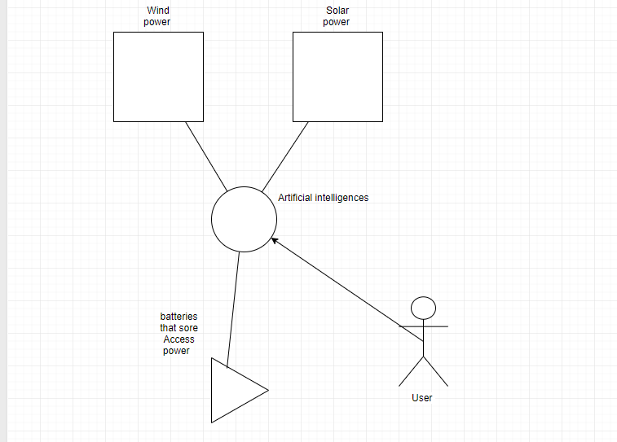

(Researcher, 2018)

# CHAPTER 3: METHODOLOGY

## INTRODUCTION

The previous Chapter had a lot of research that were done by different researcher on the 3-different subject matter, wind power is generation, Solar energy generation, and finally Artificial intelligences, the three above statements was discussed in CHAPTER 2: LITERATURE STUDY . This chapter will aim to discuss the other types of methodology that will be used to capture the accurate information in order to promote the idea of an Artificial intelligences system running a Smart grid in terms of the distribution. The researcher will be using the previous chapters literature that was references as a base for most of the assumptions and most of the conclusions will be mostly from the existing literature, Chapter 2 contains a lot of existing research as well as some of the researcher own research and the researcher own diagram of the proposed system

## RESEARCH QUESTION

The Research question in chapter 1 asked the very important questions, how does ARTIFICIAL INTELLIGENCE effect clean electrical power distribution? Seeing as there are a lot of literature on the subject of Artificial intelligence, clean power generation using that as n base to answer the research question but the answer will use the literature as refence and support for the statements that the researcher will make. However, the literature will not be the only prove that will be provided to support the statements even more there will be Quantitative Research the data will come for online survey that will be distributed then the data will be analyzed by using analytic software to provided visual representation of the data in the form of graphs these include pie charts histograms and bar graphs etc. to help strengthen the answer provided more hypnosis testing will be done it is a form of statistical analyses to help prove the answer no only theoretical but to show that the math’s works behind it.

## RESEARCH PHILOSOPHY

Qualitative Research is mainly used is Exploratory research. It is used to understand the underlying reasons, opinions and motivations for doing the researcher in the first place. It provides a in dept look into problem or helps to develop the hypotheses for a quantitative research. Qualitative Research is also used to uncover trends in thought and opinions, and dive deeper into the problem. Quantitative Research is used to quantify the problem by way of generating numerical data or data that can be transformed into usable statistics. It is used to quantify attitudes, opinions, behaviors, and other defined variables – and generalize results from a larger sample population. Quantitative Research uses measurable data to formulate facts and uncover patterns in research. Quantitative data collection methods are much more structured than Qualitative data collection methods. Quantitative data collection methods include various forms of surveys – [online surveys](https://www.snapsurveys.com/online-surveys/), [paper surveys](https://www.snapsurveys.com/paper-surveys/), [mobile surveys and kiosk surveys](https://www.snapsurveys.com/mobile-surveys/), face-to-face online surveys , telephone online surveys , longitudinal studies, website interceptors, online polls, and systematic observations. (Snap Survey, 2018)

So, in the case of the research online surveys will be used to get the data form the normal non-researcher’s perspective The Qualitative researcher will be used in the all the literature mentioned in chapter 2 this is done to make sure that the amount of information display can be adapted and incorporated into a well-formed hypnosis that can ultimately be answered in a Quantitative data that will be retrieved from the online surveys that will be filled in by people who specifically live in South Africa . The nature of this research is expletory seeing as most of the research is done in the 3 individual fields consisting of Artificial intelligences solar and wind generation the definition of Exploratory Research is: exploratory research studies that are merely formative, for the purpose of gaining new insights, discovering new ideas, and increasing knowledge of phenomena. (The free Dictionary , 2018) The new insights that this research Artificial intelligence ms to provide is the idea of using Artificial intelligences to more Effectively manage the distribution of the electricity generated

## RESEARCH APPROACH

Deductive reasoning works from the more general to the more specific. Sometimes this is informally called a "top-down" approach. We might begin with thinking up a theory about our topic of interest. We then narrow that down into more specific hypotheses that we can test. We narrow down even further when we collect observations to address the hypotheses. This ultimately leads us to be able to test the hypotheses with specific data -- a confirmation (or not) of our original theories. (socialresearchmethods, 2018)

Deductive Approach

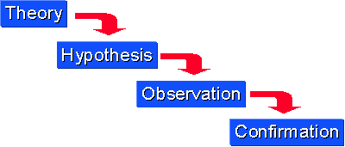

Figure 4 Deductive Approach (socialresearchmethods, 2018)

Inductive reasoning begins with specific observations or real examples of events, trends, or social processes and progresses analytically to broader generalizations and theories based on those observed cases. This is sometimes called a “bottom up” approach because it starts with specific cases on the ground and works its way up to the abstract level of theory. With this method, once a researcher has identified patterns and trends amongst a set of data, he or she can then formulate some hypotheses to test, and finally develop some general conclusions or theories.

A classic example of inductive reasoning within sociology is the premise of Émile Durkheim's study of suicide. Considered one of the first works of social science research, the famous and widely taught book, Suicide, details how Durkheim created a sociological theory of suicide -- as opposed to a psychological one -- based on his scientific study of suicide rates among Catholics and Protestants. Durkheim found that suicide was more common among Protestants than Catholics, and he drew on his training in social theory to create some typologies of suicide and a general theory of how suicide rates fluctuate according to significant changes in social structure and norms.

However, while inductive reasoning is commonly used in scientific research, it is not always logically valid because it is not always accurate to assume that a general principle is correct based on a limited number of cases. Some critics have suggested that Durkheim's theory is not universally true because the trends he observed could possibly be explained by other phenomena particular to the region from which his data came. (Crossman, 2018)

#### Inductive Approach

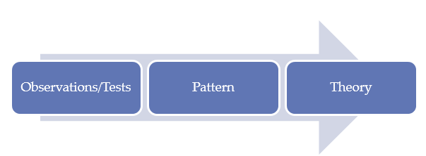

Figure 5 Inductive Approach (Dudovskiy, 2018)

For the research approach the researcher will not exclusively be using deductive or inductive but rather a mix between the two so there will be theories that will be made before the researcher start the researching and then again, some hypnosis will be made after the research is done

## POPULATION AND SAMPLING

The sample is the group of individuals who actually participate in your study. These are the individuals who you end up interviewing (e.g., in a qualitative study) or who actually complete your survey (e.g., in a quantitative study). People who could have been participants in your study but did not actually participate are not considered part of your sample. For example, say you e-mailed study invitations to 200 people on a listserv and 100 of them end up participating in your study (i.e., complete your survey or your experiment). Your sample is the 100 individuals who participated in your study. The 100 individuals who received invitations but did not participate would not be considered part of your sample; rather, they are part of what is often called the sampling frame. Your sampling frame is the group of individuals who could possibly be in your study. On the other hand, your population is the broader group of people to whom you intend to generalize the results of your study. Your sample will always be a subset of your population. Your exact population will depend on the scope of your study. For instance, say your research question asks if there is an association between emotional intelligence and job satisfaction in nurses. In this case, your population might be nurses in the United States. However, if the scope of your study is narrower (e.g., if your study deals with a local problem or a specific specialty/industry), then your population would be more specific, such as “nurses in the state of Florida” or “licensed practical nurses in the United States.” Importantly, your population should only include people to whom your results will apply. For example, if you do not have good reason to believe that your results will apply to all nurses in the United States, then your population will need to be more specific. If you are stuck on defining your population, think about how you would fill in the blank in the following sentence: “The results of my study will apply to _____.” Your answer will help determine how you define your population. A general rule of the thumb is to always use the largest sample possible. The larger the sample the more representative it is going to be, smaller samples produce less accurate results because they are likely to be less representative of the population. The literature reviewed indicated that challenges exist even before contraceptive use can be initiated, and during the use of contraceptives. The structured interview tool was formulated to capture contraceptive challenges facing women before contraceptive use can be initiated, and those that are experienced during the use of contraceptives. The structured interview schedules (David, 2018).

For the purpose of this research the population will be kept at a Statically significant size of between 20 and 25 people the reason for the small size is that the survey will be more an option based one and very few facts will arise from the survey but their will still be a couple that will be required in answering the research Question

## DATA COLLECTION

For the purposes of this research, online surveys were used. Online surveys, whose Artificial intelligence m is to identify opinions regarding a particular research subject. and direct contact between interviewers and interviewees, as What is more, unstructured online surveys offer flexibility in terms of the flow of the interview, thereby leaving room for the generation of conclusions that were not initially meant to be derived regarding a research subject. However, there is the risk that the interview may deviate from the prespecified research aims and objectives (Gill & Johnson, 2002). As far as data collection tools were concerned, the conduction of the research involved the use of semi-structured questionnaire, which was used as an interview guide for the researcher. Some certain questions were prepared, so as for the researcher to guide the interview towards the satisfaction of research objectives, but additional questions were made encountered during the online surveys. Some sample questions that were included in the semi-structured questions were the following

Question 1: Do you know what Artificial intelligence is?

Question 2: Do you think that the way electrical power distribution is Handled in South Africa is effective?

Question 3: Artificial intelligence (ARTIFICIAL INTELLIGENCE) it refers to the ability of a machine to preform task that is associated with human intelligence. Do you think that ARTIFICIAL INTELLIGENCE can improve the way Electrical power is distributed?

Question 4: Do you Think solar and wind electrical power generation is important?

Question 5: Do you think that solar and wind electrical power generation can help improve the load on the current power grid?

Question 6: Do you think that if solar and wind electrical power generation were to be integrated in the current power grid the distribution of the clean power will be effective?

## DATA ANALYSIS

A large set of data sitting in a spreadsheet does not help us to understand the characteristics of the population we are working with or describe the changes brought about by our projects. We need to use the data to create information. In our case study example, we may have interviewed children working on the street in Karachi and collected all the data together in a spreadsheet; however, we need to analyses and summaries the data to answer our research questions. We need to understand what percentage of children are involved in different work types. For instance, we may want to understand if girls and boys carry out similar tasks or are exposed to similar risks. Statistics help us turn quantitative data into useful information to help with decision-making. We can use statistics to summaries our data, describing patterns, relationships and connections. Statistics can be descriptive or inferential. Descriptive statistics help us to summaries our data whereas inferential statistics are used to identify statistically significant differences between groups of data (such as intervention and control groups in a randomized control study). During this module our focus will be on descriptive rather than inferential statistics: this will also help to give a short introduction to the most common descriptive statistics. (The open University, 2010)

The only data that will be analyzed will be the data from the surveys, seeing as the case studies will come from trusted sources so the information does not be refined to draw a conclusion. The survey data will be refined by using hypothesis testing algorithm and all the correlating statistical algorithms to refine the data so that it is less technical and more readable and understandable. The existing literature on the subject will sourced and use as a prove that the concept is not far-fetched and that it is not only theoretical possible but also practically doable and more immortally it is implementable.

The Mathematical proofs that will be used include propositional logic, petri nets and combinatorics and graph theory. Propositional logic will help express the simple facts of the research in an attempt to make it less technical for the less technical reader. Petri nets this notation is suitable for explaining the dynamic aspects for the system to give the more technical user a better understanding of what this research as found on the subject of Artificial intelligence and how it can be integrated into a clean energy grid to make it a smart grid. Combinatorics and graph theory this type of Mathematical proof is a branch that deals with the arrangement or ordering of discrete entities it will attempt to answer given entities that are arranged according to a specific pattern what are the characteristics of such arrangements this is a more visual strategy. This type of proof is of much interested in the information technology because it can describe various entities and their attributes and property’s.

## LIMITATIONS

There are a couple of limitations that will obstruct the research and my impact the accuracy of the research. This decrease in accuracy can be ignored the researcher will not publish inaccurate calculations, but the limitations that impacts is paper is, time constraint is a big limitation seeing as this research as a deadline of 6 moths the ideal time would have been a 1 year to conduct interview as well as increasing the population size. A big limitations that the researcher faces is the surveys is filled in by random user and that might not have the research best interest at heart meaning they might impact the accuracy of the research.

## ETHICAL CONSIDERATIONS

Informed consent is the major ethical issue in conducting research. According to Armiger: "it means that a person knowingly, voluntarily and intelligently, and in a clear and manifest way, gives his consent".

Informed consent is one of the means by which a patient's right to autonomy is protected. Beauchamp and Childress define autonomy as the ability for self-determination in action according to a personal plan. Informed consent seeks to incorporate the rights of autonomous individuals through self- determination. It also seeks to prevent assaults on the integrity of the patient and protect personal liberty and veracity. Of course, individuals can make informed decisions in order to participate in research voluntarily only if they have information on the possible risks and benefits of the research. Free and informed consent needs to incorporate an introduction to the study and its purpose as well as an explanation about the selection of the research subjects and the procedures that will be followed. It is essential to describe any physical harm or discomfort, any invasion of privacy and any threat to dignity as well as how the subjects will be compensated in that case. In addition, the subjects need to know any expected benefits either to the subject or to science by gain new knowledge. A disclosure of alternatives is also required as for example in the Tuskegee study about syphilis. In this study, rural black men were chosen as subjects in a study of syphilis. Although a cure for syphilis was found after the start of the study, it was decided not to treat them and they had not been told that penicillin was effective to their disease. The researcher must inform the subjects about the methods which will be used to protect anonymity and confidentiality and indicate a person with whom they can discuss the study. He must also provide a "Noncoercive Disclaimer" which states that participation is voluntary and no penalties are involved in refusal to participate. Moreover, the subject must be told that some information has been deliberately withheld in order to avoid altered behaviors. The researcher must also take into account that persons with physical, cultural and emotional barriers may require a very simple language in order to understand him. Finally, the freedom to withdraw must be explained. This is very important but raises the issue of how difficult the subjects can withdraw after developing a personal and sometimes friendly relationship with the researcher. With regard to withdrawal a researcher may be in a dilemma in case many subjects choose to withdraw at an advanced stage of the study, because this can affect the validity of the results. The Declaration of Helsinki provide some help as it declares that the interest of the subject must always prevail over the interests of society and science. According to this, the will of the subject must be respected at any cost for the research.

## TRUSTWORTHINESS

Qualitative research may include multiple methods such as, case studies, ethnography and participant observation, grounded theory, biographical and participative inquiries (Strauss/Corbin 1994). Within the field of qualitative IB research, the case study methodology is the most prevalent method. Similarly, there are a range of specific methods for collecting empirical material, such as interviewing, observational techniques, semiotic analysis etc. The analysis of text-based in-depth online surveys is the most widely employed methodology for firm-level IB research, as published material in major journals such as, Journal of International Business Studies (JIBS), Management International Review (MIR), Journal of World Business (JWB) and International Business Review (IBR) reveal (Ghauri, 2008)

The results from the selected dissertations of students from the School of Education of the University of Dar es Salaam–showed that most of them who opted to use the qualitative inquiry approach used quantitative trustworthiness criteria to ensure the integrity of their research findings. The findings indicated that of 245dissertations that employed the qualitative methodology, 238 used the quantitative trustworthiness criteria of validity and reliability to ensure the credibility of the research instruments and the authenticity their findings, while only 7 dissertations used the qualitative criteria. Likewise, dissertations from the Open University of Tanzania revealed similar results as 64 dissertations used the quantitative criteria to ensure the authenticity of the instruments and findings, while only 14dissertations used the correct qualitative criteria of dependability, confirmability, credibility and transferability. The extracts from students’ dissertations are presented in Tables 2 and 3 from Faculty/School of the University of Dares Salaam and Open University of Tanzania. The researcher did not present all the extracts from the dissertations because the data had reached saturation point since all the students had used similar strategies in their dissertations. (Anney, 2014)

## CONCLUSION

In conclusions this chapter highlighted the methodologies the researcher will using in order to find data as well make sure that the data is accurate and will formatted so that the reader can feel assured that the data that is obtained is done ethically and that the limitations the researcher does face constraint and some of this is outside of the researchers control and he cannot change then

# CHAPTER 4: RESULTS AND CONCLUSIONS

## INTRODUCTION

This chapter will be focusing on the findings of the surveys and compiling it in a readable manner. The complied results will be for the sole purpose of answering the research question. This chapter will also give a visual representation for the data. The combination of Artificial intelligent into the clean power energy Grid is a natural step forward to better managing our clean electrical grid.

## THE RESEARCH PROBLEM AND QUESTION

How will Artificial intelligent effect clean electrical power distribution? This was the question asked in chapter 1 the methodology Artificial intelligence med to address what clean energy is and how it is generated and what Artificial intelligent. The methodology also addressed how the people of South Africa feel about the current electrical situations and what the think About the idea of using Artificial intelligent to handle distribution instead of human operators this brings me to my next question; How will the incorporation of ARTIFICIAL INTELLIGENCE affect the industry in the short and long term? This Question is Artificial intelligence med to address the possible influence of the incorruptions of the Artificial intelligent into the grid seeing as that Artificial intelligent is better at making desiccations and to getting emotional over dissections made by the “higher ups”, this was the reason behind this question (How will the incorporation of ARTIFICIAL INTELLIGENCE affect the industry in the short and long term?).

## DISCUSSION OF RESULTS

The researcher has done both Qualitative study and a Quantitative as mentioned in chapter 3. Chapter 2 showcase some of the literature on the induvial subjects but now the researcher will combine the idea of all the different subjects into one as was indented for the researcher to show that the way we are currently handling electrical power disruption is ineffective the ability to store energy on a large scale would be a game-changer, since it would mean that more demand wouldn't necessarily have to be met with more **generation**. The chart below shows exactly that

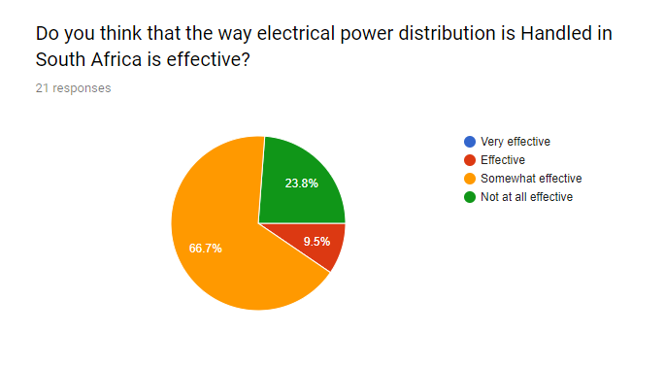

Figure 4.3 DO you think distortion is effective (Researcher, 2018)

Consider the water industry. "They don't really care when you use you water," Seal says. "If there were anything like that in the electricity industry it would really change a lot about how efficiently we can use the system, about how reliable the system is."

Although they make only a small impact on the whole, a few storage methods do already exist. Some utilities store energy underground in the form of compressed Artificial intelligence r. Another way, known as pumped hydro, involves using excess electrical energy to pump water uphill. When that energy is needed, the water is allowed to run back down hill and turn a turbine. But these methods are limited because they require specific geographical characteristics. Electrochemical devices, like batteries and flywheels could also be used to store energy for the grid—especially if they can be scaled up significantly. The federal energy department has made energy storage one of its top priorities for research and development. (Orcutt, 2010)

The need to produce clean energy has never be grate seeing as our coal resource is become very expensive to mine as shown in the graph below and seeing as we are currently struggling with the distribution as well simply integrating solar and wind power generation is not enough wee something more precise than humans and more efficient workers that humans well the answer is Artificial intelligent.

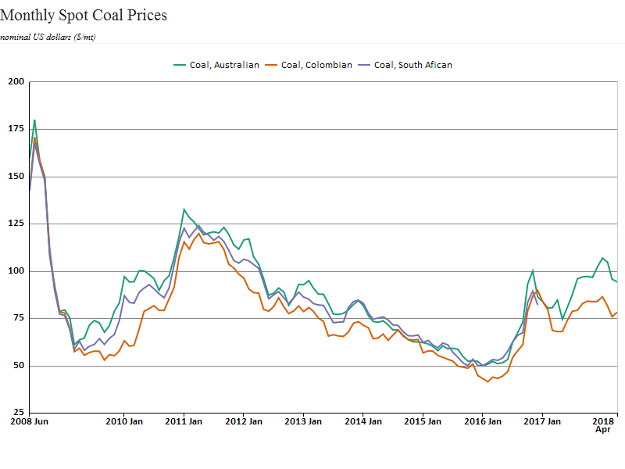

Figure 4.3 Coal prices in SA Austral and Colombia (Saticstics SA, n.d.)

The graph above prove that coal is very expensive. To generate power from coal takes a lot of coal because of the high amount of energy required to make super-heated steam which is way is used to turn the turbines. In contras where the research has proven that the hole sample population agrees that clean energy generation is important as shown in the graph below

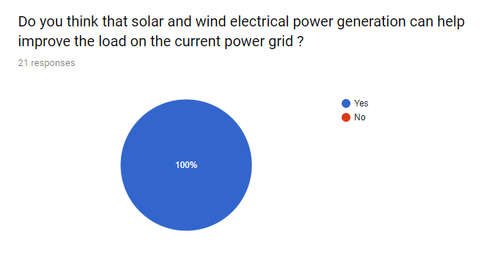

Figure 4.3 Do you think that solar and wind power is important (Researcher, 2018)

The researcher has established that the population of the sample 81% of them know what Artificially intelligent is and 19 % not

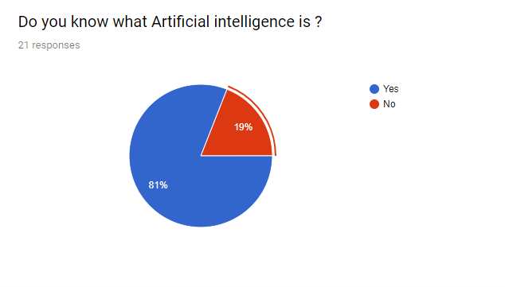

Figure 4.3 do you know what artificial intelligence is (Researcher, 2018)

After a brief explanation of what Artificial intelligence is and what the significands it has to the power energy hand how it can improve the way we think of electrical distribution but not only electrical disruption specifically how it can improve the distribution and storage of clean energy

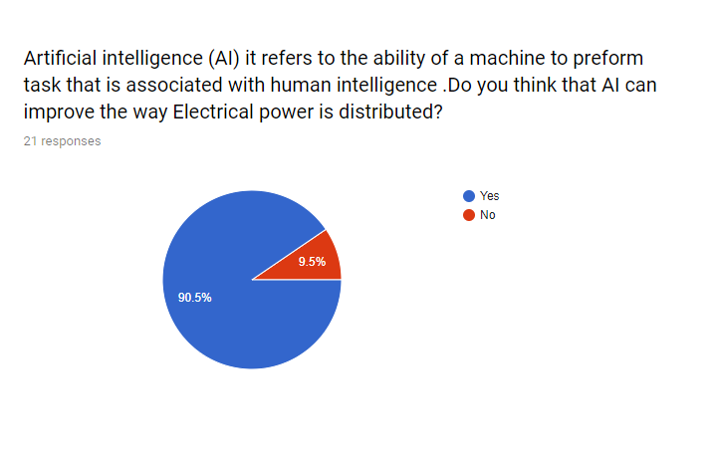

Figure 4.3 Artificial intelligence refers to the ability of a machine (Researcher, 2018)

The graph show that 90.5% of the sample population agrees that Artificial intelligence will be a better choice to use that human operators in terms of doing the discussion making regarding the power distribution is impact the study very scientifically because this is very the researches questions Is being answered.

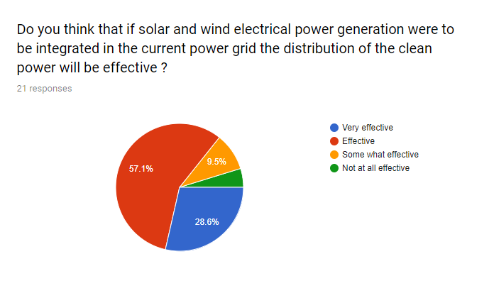The population sample intelligence d that that if the countries decides to integrate clean energy into their existing grids that this integration alone may not be enough

Figure 4.3 Do you think if solar was intergraded (Researcher, 2018)

The very effective slice is only 28.6 % of the population thinks that if change were to come that it will be effective which is really bad that slice should be bigger this where the previous graph (Figure Artificial intelligence refers to the ability of a machine) come in to consideration seeing as that the 90.5% think that if Artificial intelligence were to be integrated if will help improve the effectiveness. 61.9% of the pollution sample intelligence d that just integrating the clean energy is not enough but if Artificial intelligence will be integrated as well that it will work.

## FINDINGS

The researcher poses a hypothetical let’s say that this papier impacts the way the reader sees the current power situation in his or her country and decides to try and change it by ways of integrating clean power in to the current grid. This action alone will not help the problem at hand in fact it will cause more problems that it provides solutions if it has been decided that there will be clean energy will be integrated into the current power grid one would need to consider that this whole problem consists of both the clean energy and the inability of human operators to perform on the same level regarding the amount of work that the Artificial intelligence algorithm can do compared to the human operators. By this statement the researcher does not indented to belittle the job of operators in the energy sector. The researcher is merely saying that if a country were to integrate clean energy into their power grid consider the hypnotical stated above.

The results discussed above has made of think inertly clear a that is that one can not have only part of the research and use that as prove that clean energy should be integrated into the power grid. When and if this research is used as prove of concept one needs to take the hole research into consideration. This researcher has concluded that: The current disruption networks do not work there is a fatal flaw in the system and that it has an effect on our planet. Not only our planet but the taxpayers’ wallet the consumer of electricity which is most of the world’s population. This means that the way consumers think of power should drastically change and a more critical view of the distribution network is mandatory for this research to have an impact in the long run

This research has established the important of not only change the we generate power but the way countries distribute the generated power in the case of this research the researcher gave a practical way of solving 2 problems deceasing our carbon footprint and effectively disturbing this generated power using Artificial intelligence.

The researcher only motions Artificial intelligence algorithms and never goes into detail l how one might achieve using an Artificial intelligence algorithm to handle distribution well at the time of this researcher document Neural networking in the field of Artificial intelligence algorithms is being used as a form of Artificial intelligence

If this research will be applied in the future their might be a different more effective method of programing Artificial intelligence algorithms.

High costs for infrastructure and distribution lines, as well as stringent governmental regulations, naturally create opportunities for monopolies to develop in the market. As a result, three separate U.S. grids produce and transmit power under the mandate to provide low-cost, reliable energy as a public good.

In the U.S., the average age of power plants is over 30 years and of power transformers is over 40 years. This deteriorating transmission system led to the [2003 Northeast blackout](https://www.scientificamerican.com/article/2003-blackout-five-years-later/), the [largest failure](http://www.nytimes.com/2003/08/15/nyregion/blackout-2003-overview-power-surge-blacks-northeast-hitting-cities-8-states.html) in U.S. history according to the [federal task force](https://energy.gov/oe/downloads/blackout-2003-final-report-august-14-2003-blackout-united-states-and-canada-causes-and) charged with its investigation. It left 50 million people without power for several days when an overloaded transmission line sagged and struck a tree. Instances like these can have cascading effects on the entire regional grid and pose a difficult task for utility companies to manage.

## DISCUSSION OF CONCLUSIONS

Renewable energy technologies are clean sources of energy that have a much lower environmental impact than conventional energy technologies. Most renewable energy investments are spent on materials and workmanship to build and maintain the facilities, rather than on costly energy imports. This means your energy Rands stay home to create jobs and fuel local economies, rather than going overseas Renewable energy will not run out. Ever.

Artificial intelligence is better than humans in terms of not getting tired or a los in productivity because of sociopolitical or environmental situations and seeing this benefit Artificial intelligence is a prime candidate to improve the way electrical distribution is handled. While the evidence is clear that machine learning and ARTIFICIAL INTELLIGENCE -enabled robots will likely supplant human work, the question is how many and how soon.

analysis suggests that these developments could gather steam in the near future and apply not only to repetitive tasks but also to knowledge work. According to the McKinsey Global Institute’s report “Harnessing automation for a future that works,” [49% of work activity could be supplanted by automation](http://www.mckinsey.com/global-themes/digital-disruption/harnessing-automation-for-a-future-that-works) by 2055.

At the same time, McKinsey’s “[What’s now, what’s next in analytics, ARTIFICIAL INTELLIGENCE , and automation](http://www.mckinsey.com/global-themes/digital-disruption/whats-now-and-next-in-analytics-ai-and-automation)” compared the changes wrought by ARTIFICIAL INTELLIGENCE to those of the Industrial Revolution, where old tasks gave way to new human opportunities.  “We cannot definitively say whether historical precedent will be repeated this time," the report said. "But our analysis shows that humans will still be needed in the workforce.”

The report concluded that while technology is supplanting human activity, [digital platforms](http://www.mckinsey.com/global-themes/digital-disruption/harnessing-automation-for-a-future-that-works) from Amazon and Alibaba to Uber and Upwork and the growing importance of data analytics will create new efficiencies and opportunities in the job market.

## RESEARCH QUESTION ANSWERED?

The main goal of the research was to answer the question −How will Artificial intelligence effect clean electrical power distribution?

This research followed a condition of Qualitative and quantitative research approach there was not a lot of research done on the topic of using Artificial intelligence as a distribution method to handle all the tasks from generation to consumption so the researcher use all the literature on 3 separate subjects to formulate a case study of sorts in order to understand what Artificial intelligence is as well as how clean energy is produced

This still did not answer the question of how Artificial intelligence will impact the clean electrical power distribution this is were the second part of the study came in getting the population to answer a couple of questions about the different topics.

After all this was the complete so goal that the research could formulate the a very detailed answer to the question combining the surveys answers and that what was learned in the case study we have concluded a detailed answer.

The answer of this question is Artificial intelligence is a very power full and new type of technology and although clean power has been around for a couple of years countries has still not integrated it into their existing power grid because of the simple reason they do not have an effective way of handling distribution but when you consider the capabilities of Artificial intelligence one can start to see why it will be such an effective method to use in order to get optimal disruption. Artificial intelligence can effective the distribution of clean energy in a very very positive way but optimizing the current way of disturbing electricity

## EXCEPTIONS

The researcher mentioned that Artificial intelligence is better at performing certain tasks specifically the tasks of an operator well their might be some exceptions to that rule.

Let’s take a hypothetical scenario and let’s say there is hospital and there was a major accident somewhere so the influx of patients is a lot, now this is where the exception comes in to play a human operator will maybe see that the story on the news or hear it on the radio or whatever the case maybe the human operator will be influenced in his or her decision to cut the power. Whereas an Artificial intelligence algorithm will only se the black and white the numbers it would see the grey areas or the human side of things

## SHORTCOMINGS AND LIMITATIONS

The biggest limitation the researcher faced was the time frame a longer timeframe would have very helpful and because of the shortened timeframe there are some shortcomings.

This research did not take inconsideration the sociopolitical and socioeconomical impact of integrating clean energy into the existing grid and on top of that the impact of only using Artificial intelligence as operators. This research could also have benefitted from interviews with higher ups in the energy sector like for instance the chairman on Eskom (South African energy company) but because of the sensitive mater of the researcher could not make an appointment.

## RECOMMENDATIONS

The researcher focused on the idea of integrating clean energy into the power grid and using Artificial intelligence as a means to distribute it. This research focuses on the idea that Artificial intelligence is ‘better’ than humans at some tasks and off course this means that the current jobs there are in the energy sector will change so the recommendation the researcher makes is get training in a more modern-day skill like programming or electrical or electronical engineering.

## BENEFITS TO THE FIELD OF STUDY

A lot was said in this papier and it contributed a lot to not only individuals but entire countries.

This research was intended to draw the focus towards how we as tax payers see the current power grid and we should view the current system with the flaw and not be discourage at the sight of overwhelming odds but be motivated to change for the better and help to improve not only our environment but our country.

This research was intended to answer some of the question raised by some problems and it did although the solution is not perfect it does solve a lot of problems like the electrical energy disruption as well as how can we effectively manage and disrupted the clean energy

## PROPOSED NEW RESEARCH

The researcher also recommends any future research that will be done based of this research the researcher in question should focuses more towards the sociopolitical and socioeconomical impact this type of integration and change might have on first, second and third world countries.

The researcher that will base his/her research off this papier would also might want to consider doing it solely on hydro electrical power generation and how one might go to work to integrate Artificial intelligence in the disruption network of specifically the hydro electrical power grid.

## FINAL CONCLUSION

“Some people call this artificial intelligence, but the reality is this technology will enhance us. So instead of artificial intelligence, I think we'll augment our intelligence.” —Ginni Rometty

Artificial intelligence is indeed the future and not only in general but especially in energy sector. This research was done in a time were artificial intelligence was busy taking over multiple sectors and the hole concern around renewable energy is a huge issue. That is why the researcher decided to do this research and try and solve the problem concerning how clean energy will be, and is disturbed

Research concerning this idea is not done at all seeing as this field Is continently evolving there is still a lot more research that can be done. Artificial intelligence is slowly becoming an industry standard across different sectors this means that their will still follow a lot more research on this papier by either the researcher of this papier himself or by different researchers because there are a lot of aspects conserving specifically around Artificial intelligence that was not covered in this research this means this research is only the beginning.

This research can and will help a lot of people in a positive way because if integration is optimized on a clean energy grid consumers and companies can save a lot of money because a optimized clean grid means less load on storage mediums and electrical power generating equipment and less load on the hardware means less equipment maintains which have a direct impact on how much sthe user will pay at the end of the day

# REFERENCES

## Anney, V. N., 2014. Ensuring the Quality of the Findings of Qualitative Research:. *Journal of Emerging Trends in Educational Research and Policy Studies ,* pp. 272-281.

Association, T. b. w. e., 2004. *BWEA Briefi ng Sheet,* London: The british wind energy Association.

Avneet Pannu, M. T. S., 2015. Artificial Intelligence and its Application in. *International Journal of Engineering and Innovative Technology (IJEIT),* pp. 79-84.

Bekele, G., 2009. *STUDY INTO THE POTENTIAL AND FEASIBILITY OF A STANDALONE SOLAR WIND HYBRID ELECTRIC ENERGY SUPPLY SYSTEM ,* Stockholm: Universitetsservice US AB Stockholm.

Copeland, B., 2018. *Artificial intelligence.* [Online]   
Available at: https://www.britannica.com/technology/artificial-intelligence

Crossman, A., 2018. *Deductive vs Inductive Reasoning - What's the Difference?.* [Online]   
Available at: https://www.thoughtco.com/deductive-vs-inductive-reasoning-3026549

David, 2018. *What is the Difference Between Population and Sample?.* [Online]   
Available at: http://www.statisticssolutions.com/what-is-the-difference-between-population-and-sample/

Dudovskiy, J., 2018. *Inductive Approach (Inductive Reasoning).* [Online]   
Available at: https://research-methodology.net/research-methodology/research-approach/inductive-approach-2/

Ekins-Daukes, D. N., 2009. *Solar energy for heat and electricity:,* London: Imperial College.

Foundational Research Institute, 2015. *Artificial Intelligence: Opportunities and Risks,* s.l.: Foundational Research Institute.

Geoffrey Jones, L. B., 2012. *“Power from Sunshine”: A Business History of Solar Energy,* Boston: Harvard business school.

Ghauri, R. R. S. ·. E. P. ·. P. N., 2008. *Enhancing the Trustworthiness of Qualitative,* s.l.: MIR.

Giglmayr, S., 2013. *Development of a Renewable Energy Power Supply Outlook 2015 for the Republic of South Africa,* Stellenbosch: Fachhochschule Technikum Wien.

Govinda R. Timilsina, L. K. A. N., 2011. *A Review of Solar Energy,* s.l.: The World Bank, Development Research Group,Environment and Energy Team.

Hantula, R., 2010. *How Do Solar panels work,* New York: Chelsea culb house.

McDermott, D., 2007. Artificial Intelligence and Consciousness. In: *The Cambridge Handbook of Consciousness.* conceticut: Yale University, pp. 117-150.

Orcutt, M., 2010. *How a Smarter Grid Can Prevent Blackouts—and Cut Your Energy Bills.* [Online]   
Available at: https://www.popularmechanics.com/science/energy/a6013/how-a-smarter-grid-can-prevent-blackouts/

Researcher, T., 2018. *The purposed ,* Petoria : Belgium campus.

Saticstics SA, n.d. *Coal Prices Forecast: Long Term 2018 to 2030 | Data and Charts.* [Online]   
Available at: http://southafrica.opendataforafrica.org/xfakeuc/coal-prices-forecast-long-term-2018-to-2030-data-and-charts

Snap Survey, 2018. *What’s the difference between qualitative and quantitative research?.* [Online]   
Available at: https://www.snapsurveys.com/blog/qualitative-vs-quantitative-research/

socialresearchmethods, 2018. *Deduction and Induction.* [Online]   
Available at: https://socialresearchmethods.net/kb/dedind.php

The free Dictionary , 2018. *research.* [Online]   
Available at: https://medical-dictionary.thefreedictionary.com/Exploratory+research

The open University, 2010. 6 Methods of data collection and analysis. *Monitoring, Evaluation,Accountability and Learning (MEAL),* pp. 2-30.

University of Pretoria, n.d. *CHAPTER 4 RESARCH DESING AND METODOLOGY,* Pretoria: University of Pretoria.

Vaibhav J. Babrekar, h. D. B. A. R. B., 2017. Review Paper on Hybrid Solar-Wind Power Generator. *International Journal of Computer Applications (0975 – 8887),* pp. 36 -40.

Xi Fang, S. M. G. X., 2017. *SMART GRID – THE NEW AND IMPROVED POWER GRID,* Arizona : Arizona State University.

# APPENDIX A: DATA COLLECTION INSTRUMENTS

https://docs.google.com/forms/d/e/1FAIpQLSdaOQ0T1MTX9vc_GFvxHb64ItxRH627JHkycaO_5RQ2M78VWw/viewform

# APPENDIX B: LETTERS OF PERMISSION AND CONSENT

# APPENDIX C: TOPIC